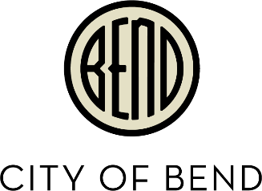
Agenda
Transportation Funding Council Subgroup
Wednesday, November 20, 2019
10:00 a.m. to 12:00 p.m.
City Council Chambers, Bend City Hall
710 NW Wall, Bend, Oregon

10:00 a.m. Transportation Funding Council Subgroup Meeting

- Roll Call: City Councilor Gena Goodman-Campbell, Councilor Bill Moseley, CTAC Co-Chair Mike Riley, CTAC Co-Chair Karna Gustafson

- Introduction/ Overview

- Guiding Principles

- Specific Project Discussion

- Project Phasing Alternatives

- Potential Package Amounts

- Determine Follow Up Items

- Adjourn

_____________________________________________________________________

Accessible Meeting Information
This meeting/event location is accessible. Sign and other language interpreter service, assistive listening devices, materials in alternate format such as Braille, large print, electronic formats, language translations or any other accommodations are available upon advance request at no cost. Please contact the Deputy City Recorder no later than 48 hours in advance of the meeting at kduddy@bendoregon.gov, 541-388-5505, fax 541-385-6676, or TTY 541-312-8478. Providing at least 2 day’s notice prior to the event will help ensure availability.

