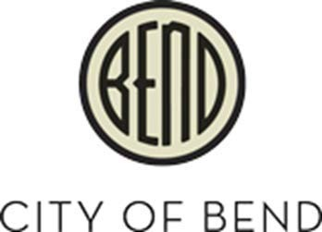
Agenda

BEDAB Strategic Working Group Wednesday, March 22,2023

Hybrid Meeting

Awbrey Butte, 2nd floor,
710 NW Wall, Bend, Oregon

12:00 p.m. BEDAB Strategic Working Group Meeting

- Roll Call: Travis Davis, Keith Dodge, Kelly Kearsley, Tierney Booker, Don Myll, Damian Syrnyk

Discuss Scope
- Subcommittee role and meeting frequency
- Planned timeline, inclusion in Council Goals, and interaction with planned Economic Opportunities Analysis
- Feedback on timeline-
- What’s missing?
- Individual participation in specific components
- Stakeholders I’m missing
- Roundtable
- Adjourn

Accessible Meeting/Alternate Format Notification


This meeting/event location is accessible. Sign and other language interpreter service, assistive listening devices, materials in alternate format such as Braille, large print, electronic formats, language translations or any other accommodations are available upon advance request at no cost. Please contact the City Recorder no later than 24
hours in advance of the meeting at rchristie@bendoregon.gov, 541-388-5505, fax 541-385-6676, or TTY 541-312-8478. Providing at least 2 days notice prior to the event will help ensure availability.

