Landscaping Design

The design of our landscape and garden areas can play a role in water quality. An effective design can minimize the need for pesticides, fertilizers, and over-water use that could lead to stormwater runoff. When pollutants get into a storm drain, they drain into the ground or directly into the Deschutes River typically with no treatment at all. The river provides important habitat for fish and wildlife, along with numerous recreational opportunities—an irreplaceable resource. Our underground aquifers are an important drinking water source.

“To protect the Deschutes River and our drinking water quality through better landscape design, I pledge to:

- Understand my landscape and garden area characteristics before designing or making changes to it.

- Choose pest-resistant plants appropriate for the soil/sun conditions in my yard.

- Use native plants that have evolved for our natural soils, climates and pests and are therefore more pest resistant and drought tolerant and require fewer fertilizers.

- Group plants with similar watering needs together.

- Use drip irrigation, proper water zones, and SMART controllers to make my watering more efficient.

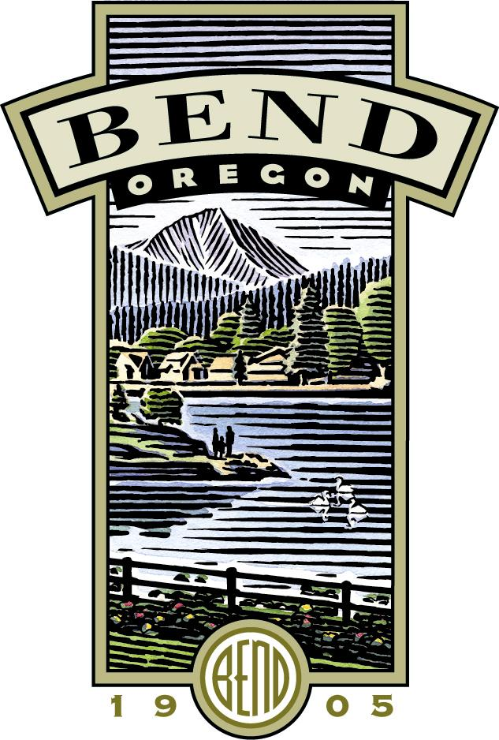
Signature: ___________________ Zip Code: __________

Thank You for Becoming A City of Bend Stormwater Steward!

